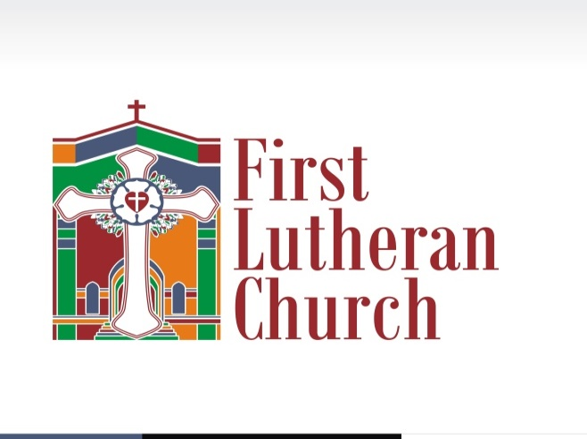
10 am Service
Worship for Summer 2020

PRELUDE
ANNOUNCMENTS
PRELUDE

CONFESSION AND FORGIVENESS LBW 77
P: In the name of the Father, and of the ☩ Son, and of the Holy Spirit.
C: Amen.
P: Almighty God, to whom all hearts are open, all desires known, and from whom no secrets are hid: Cleanse the thoughts of our hearts by the inspiration of your Holy Spirit, that we may perfectly love you and worthily magnify your holy name, through Jesus Christ our Lord.
C: Amen.
P: If we say we have no sin, we deceive ourselves, and the truth is not in us. But if we confess our sins, God who is faithful and just will forgive our sins and cleanse us from all unrighteousness.
At this time you may either kneel or stand
P: Most merciful God,
C: We confess that we are in bondage to sin and cannot free ourselves. We have sinned against you in thought, word, and deed, by what we have done and by what we have left undone. We have not loved you with our whole heart; we have not loved our neighbors as ourselves. For the sake of your Son, Jesus Christ, have mercy on us. Forgive us, renew us, and lead us, so that we may delight in your will and walk in your ways, to the glory of your holy name. Amen
P: Almighty God, in his mercy, has given his Son to die for us and, for his sake, forgives us all our sins. As a called and ordained minister of the Church of Christ, and by his authority, I therefore declare to you the entire forgiveness of sins, in the name of the Father, and of the Son and of the Holy Spirit.
C: Amen
PROCESSIONAL HYMN
APOSTOLIC GREETING LBW 78
P: The grace of our Lord Jesus Christ, the love of God, and the communion of the Holy Spirit be with you all.
C: And also with you.
KYRIE LBW 78

HYMN OF PRAISE “Glory to God” LBW 79

PRAYER OF THE DAY LBW 82
THE FIRST LESSON
PSALM OF THE DAY
THE SECOND LESSON
GOSPEL ACCLAMATION LBW 83
THE HOLY GOSPEL ACCORDING TO… LBW 83
THE GOSPEL IS READ

SERMON

APOSTLES CREED LBW 85
I believe in God, the Father almighty, creator of heaven and earth.

I believe in Jesus Christ, his only Son, our Lord.
He was conceived by the power of the Holy Spirit and born of the virgin Mary.
He suffered under Pontius Pilate, was crucified, died, and was buried. He descended into hell.
On the third day he rose again. He ascended into heaven, and is seated at the right hand of the Father. He will come again to judge the living and the dead.

I believe in the Holy Spirit, the holy catholic Church, the communion of saints, the forgiveness of sins, the resurrection of the body, and the life everlasting. Amen

PRAYERS OF THE PEOPLE LBW 85
Our prayers are gathered, collected and said as one people. As the church our individual prayers are united into one voice. Notice the one response; it is not “hear our prayers” but “hear our prayer.” We pray as members of one body.
After each petition
P: Lord, in your mercy, C: hear our prayer.
CLOSING PETITION
P: Into your hands, O Lord, we commend all for whom we pray, trusting in your mercy; through your Son, Jesus Christ our Lord. C: Amen
TITHES AND OFFERING We offer ourselves, our time and our possessions to God to serve this community and world entrusted to our care. Though we aren’t physically together, you can offer many things to our Lord.
Some ideas:
Ourselves: call your pew neighbors, share the service with a friend online, write an encouraging note to your pastor or church employee, read the Bible and listen for God’s voice in the quiet.
Our time: Weed a flowerbed at the church, offer to do an errand for a friend, make a prayer shawl, send a note.
Our possessions: Give Plus app: Download the app, find our church, give your tithe. As God is faithful to us, may we return our gifts to be used for His Glory.
Checks can be mailed to the church at 1701 19th St. Parkersburg, WV 26101- the mailbox is checked daily.
OFFERTORY
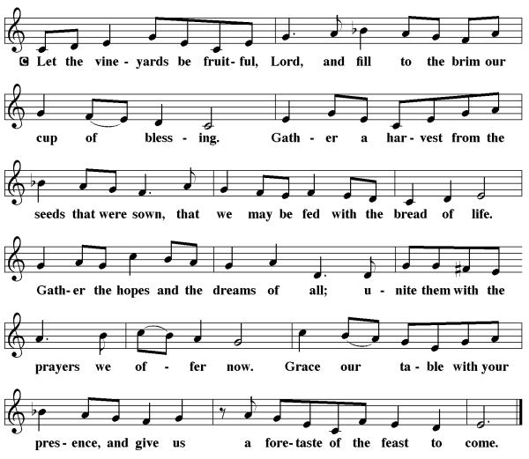
OFFERTORY PRAYER
P: Let us pray:
P: Merciful Father,
C: We offer with joy and thanksgiving what you have first given us- ourselves, our time, and our possessions, signs of your gracious love. Receive them for the sake of him who offered himself for us, Jesus Christ our Lord. Amen
GREAT THANKSGIVING DIALOUGE LBW 88
PROPER PREFACE FOR
SANCTUS LBW 89

EUCHARISTIC PRAYER LBW 69
Holy God, mighty Lord, gracious Father : Endless is your mercy and eternal your reign.

You have filled all creation with light and life; heaven and earth are full of your glory.
Through Abraham you promised to bless all nations. You rescued Israel, your chosen people.
Through the prophets you renewed your promise; and, at this end of all the ages, you sent your Son, who in words and deeds proclaimed your kingdom and was obedient to your will, even to giving his life.

In the night in which he was betrayed, our Lord Jesus took bread, and gave thanks; broke it, and gave it to his disciples, saying: Take and eat; this is my body, given for you. Do this for the remembrance of me.

Again, after supper, he took the cup, gave thanks, and gave it for all to drink, saying: This cup is the new covenant in my blood, shed for you and for all people for the forgiveness of sin. Do this for the remembrance of me.

For as often as we eat of this bread and drink from this cup we proclaim the Lord's death until he comes. C: Christ has died. Christ is risen. Christ will come again.
Therefore, gracious Father, with this bread and cup we remember the life our Lord offered for us. And, believing the witness of his resurrection, we await his coming in power to share with us the great and promised feast. C: Amen. Come, Lord Jesus.
Send now, we pray, your Holy Spirit, the spirit of our Lord and of his resurrection, that we who receive the Lord's body and blood may live to the praise of your glory and receive our inheritance with all your saints in light. C: Amen. Come, Holy Spirit.
Join our prayers with those of your servants of every time and every place, and unite them with the ceaseless petitions of our great high priest until he comes as victorious Lord of all
LBW 91

THE LORD’S PRAYER LBW 91
C: Our Father, who art in heaven, hallowed be thy name, thy kingdom come, thy will be done, on earth as it is in heaven. Give us this day our daily bread; and forgive us our trespasses, as we forgive those who trespass against us; and lead us not into temptation, but deliver us from evil. For thine is the kingdom, and the power, and the glory, forever and ever. Amen.

LAMB OF GOD LBW 92
COMMUNION BLESSING
P: The body and blood of our Lord Jesus Christ strengthen you and keep you in his grace.
C: Amen

POST COMMUNION CANTICLE Page 92

POST COMMUNION PRAYER Page 94
P: Let us pray. We give you thanks almighty God that you have refreshed us through the healing power of this gift of life; and we pray that in your mercy you would strengthen us through this gift, in faith toward you and in fervent love toward one another; for the sake of Jesus Christ our Lord.
BENEDICTION LBW 95
RECESSIONAL HYMN
SENDING
P: Go in Peace and serve the Lord.
C: Thanks be to God.
POSTLUDE

