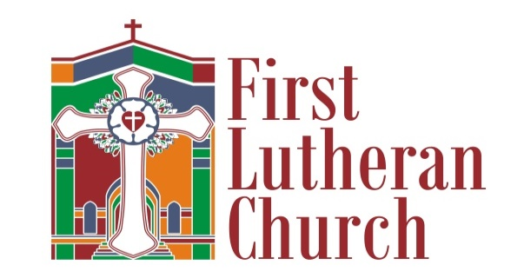
10 am in person & on Facebook Live
Sunday, April 18, 2021
Easter 3

PRELUDE: | Thee We Adore | John G. Barr

Welcome and Announcements

PRELUDE: | This Joyful Eastertide | Michael Burkhardt

*CONFESSION AND FORGIVENESS LBW 56
P: In the name of the Father, and of the ☩ Son, and of the Holy Spirit.
C: Amen.
P: Almighty God, to whom all hearts are open, all desires known, and from whom no secrets are hid: Cleanse the thoughts of our hearts by the inspiration of your Holy Spirit, that we may perfectly love you and worthily magnify your holy name, through Jesus Christ our Lord.
C: Amen.
P: If we say we have no sin, we deceive ourselves, and the truth is not in us. But if we confess our sins, God who is faithful and just will forgive our sins and cleanse us from all unrighteousness.
P: Most merciful God,
C: We confess that we are in bondage to sin and cannot free ourselves. We have sinned against you in thought, word, and deed, by what we have done and by what we have left undone. We have not loved you with our whole heart; we have not loved our neighbors as ourselves. For the sake of your Son, Jesus Christ, have mercy on us. Forgive us, renew us, and lead us, so that we may delight in your will and walk in your ways, to the glory of your Holy Name. Amen
P: Almighty God, in his mercy, has given his Son to die for us and, for his sake, forgives us all our sins. As a called and ordained minister of the Church of Christ, and by his authority, I therefore declare to you the entire forgiveness of all your sins, in the name of the Father, and of the Son and of the Holy Spirit
C: Amen
*OPENING HYMN | This Joyful Eastertide | WOV 676

*APOSTOLIC GREETING LBW 57
P: The grace of our Lord Jesus Christ, the love of God, and the communion of the Holy Spirit be with you all.
C: And also with you.

* KYRIE LBW 57
*HYMN OF PRAISE (CONGREGATION SINGS THE C PART) LBW 60
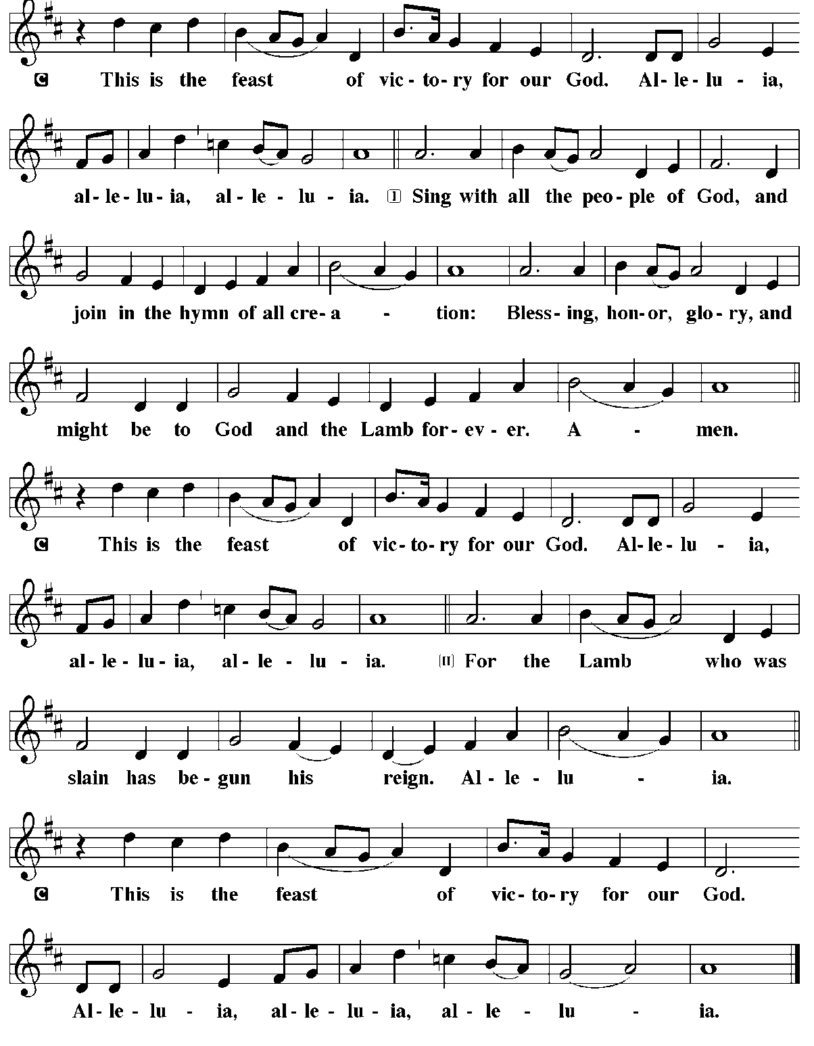

*PRAYER OF THE DAY
Almighty God, with joy we celebrate the day of our Lord’s resurrection. By the grace of Christ among us, enable us to show the power of the resurrection in all that we say and do, through Jesus Christ, our Savior and Lord, who lives and reigns with you and the Holy Spirit, one God, now and forever. Amen.

First Reading: | Acts 3:12-19
After healing a man unable to walk, Peter preaches to the people, describing how God’s promises to Israel have been fulfilled in Jesus. Through the proclamation of Christ’s death and resurrection, God is offering them forgiveness and restoration in Jesus’ name.
¹²[Peter] addressed the people, “You Israelites, why do you wonder at this, or why do you stare at us, as though by our own power or piety we had made him walk? ¹³The God of Abraham, the God of Isaac, and the God of Jacob, the God of our ancestors has glorified his servant Jesus, whom you handed over and rejected in the presence of Pilate, though he had decided to release him. ¹⁴But you rejected the Holy and Righteous One and asked to have a murderer given to you, ¹⁵and you killed the Author of life, whom God raised from the dead. To this we are witnesses. ¹⁶And by faith in his name, his name itself has made this man strong, whom you see and know; and the faith that is through Jesus has given him this perfect health in the presence of all of you.
¹⁷“And now, friends, I know that you acted in ignorance, as did also your rulers. ¹⁸In this way God fulfilled what he had foretold through all the prophets, that his Messiah would suffer. ¹⁹Repent therefore, and turn to God so that your sins may be wiped out.”
Psalm: | Psalm 4 | Psalm 133
The Lord does wonders for the faithful. (Ps. 4:3)
¹Answer me when I call, O God, defender of my cause;
you set me free when I was in distress; have mercy on me and hear my prayer.
²“You mortals, how long will you dishonor my glory;
how long will you love illusions and seek after lies?”
³Know that the Lord does wonders for the faithful;
the Lord will hear me when I call.
⁴Tremble, then, and do not sin;
speak to your heart in silence upon your bed.
⁵Offer the appointed sacrifices,
and put your trust in the Lord.
⁶Many are saying, “Who will show us any good?”
Let the light of your face shine upon us, O Lord.
⁷You have put gladness in my heart,
more than when grain and wine abound.
⁸In peace, I will lie down and sleep;
for you alone, O Lord, make me rest secure.

Second Reading: | 1 John 3:1-7
God has loved us in order to make us children of God. Though we do not yet know the full details of our future existence, we trust that God will reveal it just as God revealed Jesus to take away our sins.
¹See what love the Father has given us, that we should be called children of God; and that is what we are. The reason the world does not know us is that it did not know him. ²Beloved, we are God’s children now; what we will be has not yet been revealed. What we do know is this: when he is revealed, we will be like him, for we will see him as he is. ³And all who have this hope in him purify themselves, just as he is pure.
⁴Everyone who commits sin is guilty of lawlessness; sin is lawlessness. ⁵You know that he was revealed to take away sins, and in him there is no sin. ⁶No one who abides in him sins; no one who sins has either seen him or known him. ⁷Little children, let no one deceive you. Everyone who does what is right is righteous, just as he is righteous.

*GOSPEL ACCLAMATION LBW 62
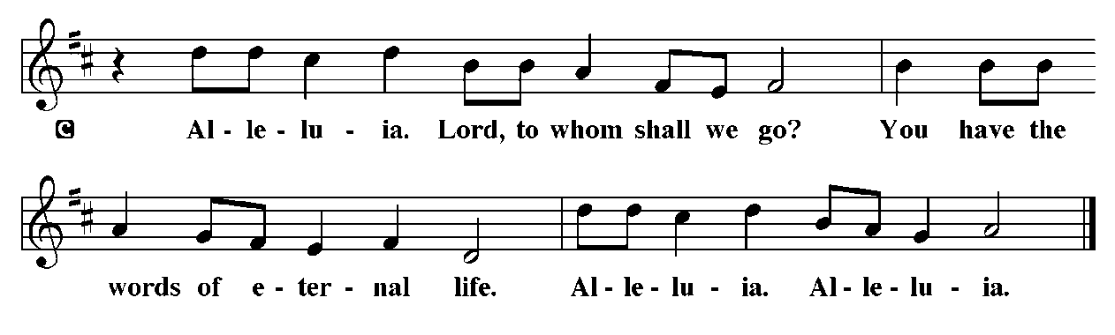
*THE HOLY GOSPEL ACCORDING TO LUKE LBW 63
*Gospel: | Luke 24:36b-48
In this account of an appearance after his resurrection, Jesus opens the minds of the disciples to understand him as Messiah. Jesus convinces them that he has been raised and sends them on a mission to proclaim the message of repentance and forgiveness.
^{36b}Jesus himself stood among [the disciples] and said to them, “Peace be with you.” ³⁷They were startled and terrified, and thought that they were seeing a ghost. ³⁸He said to them, “Why are you frightened, and why do doubts arise in your hearts? ³⁹Look at my hands and my feet; see that it is I myself. Touch me and see; for a ghost does not have flesh and bones as you see that I have.” ⁴⁰And when he had said this, he showed them his hands and his feet. ⁴¹While in their joy they were disbelieving and still wondering, he said to them, “Have you anything here to eat?” ⁴²They gave him a piece of broiled fish, ⁴³and he took it and ate in their presence.
⁴⁴Then he said to them, “These are my words that I spoke to you while I was still with you—that everything written about me in the law of Moses, the prophets, and the psalms must be fulfilled.” ⁴⁵Then he opened their minds to understand the scriptures, ⁴⁶and he said to them, “Thus it is written, that the Messiah is to suffer and to rise from the dead on the third day, ⁴⁷and that repentance and forgiveness of sins is to be proclaimed in his name to all nations, beginning from Jerusalem. ⁴⁸You are witnesses of these things.”
THE GOSPEL IS READ
SERMON Rev. Ian Reid
*NICENE CREED LBW 64
We believe in one God, the Father, the Almighty,
maker of heaven and earth, of all that is, seen and unseen.
We believe in one Lord, Jesus Christ,
the only Son of God, eternally begotten of the Father, God from God, Light from Light,
true God from true God, begotten, not made, of one Being with the Father.
Through him all things were made. For us and for our salvation he came down from heaven;
by the power of the Holy Spirit he became incarnate from the virgin Mary, and was made man.
For our sake he was crucified under Pontius Pilate; he suffered death and was buried.
On the third day he rose again in accordance with the Scriptures;
He ascended into heaven and is seated at the right hand of the Father.
He will come again in glory to judge the living and the dead, and his kingdom will have no end.
We believe in the Holy Spirit, the Lord, the giver of life, who proceeds from the Father and the Son.
With the Father and the Son he is worshiped and glorified.
He has spoken through the prophets. We believe in one holy catholic and apostolic Church.
We acknowledge one Baptism for the forgiveness of sins.
We look for the resurrection of the dead, and the life of the world to come. Amen
*PRAYERS OF THE PEOPLE LBW 65
P: Let us pray for the whole people of God in Christ Jesus, and for all people according to their needs.
P: Lord, in your mercy,
C: Hear our Prayer.

P: Into your hands, O Lord, we commend all for whom we pray, trusting in your mercy; through your Son, Jesus Christ our Lord.
C: Amen

TITHES AND OFFERING
We offer ourselves, our time and our possessions to God to serve this community and world entrusted to our care. Though we aren’t physically together, you can offer many things to our Lord.
Give Plus app: Download the app, find our church, give your tithe.
Checks can be mailed to the church at 1701 19th St. Parkersburg, WV 26101- the mailbox is checked daily.

SPECIAL MUSIC | How Beautiful | CHOIR
OFFERTORY LBW 66
OFFERTORY PRAYER LBW 68
P: Let us pray.
P: Blessed are you,
C: O Lord our God, maker of all things. Through Your goodness You have blessed us with these gifts. With them we offer ourselves to Your service and dedicate our lives to the care and redemption of all that You have made, for the sake of Him who gave Himself for us, Jesus Christ our Lord. Amen
*THE GREAT THANKSGIVING LBW 68
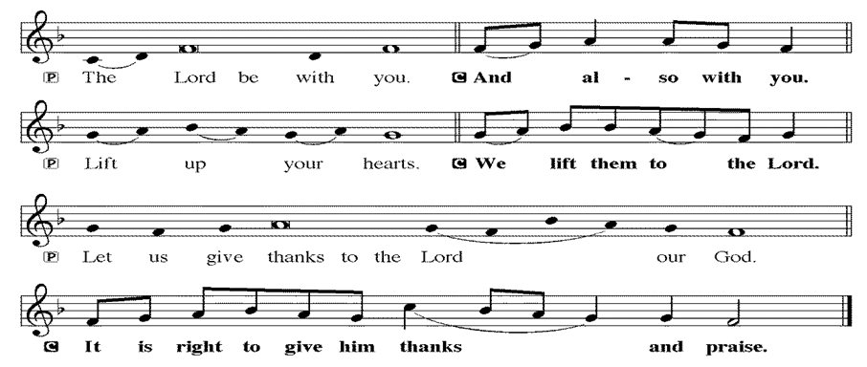
*PROPER PREFACE FOR SEASON LBW 68
P: It is indeed right and salutary that we should at all times and in all places offer thanks and praise to you, O Lord, holy Father, almighty and ever living God. But chiefly are we bound to praise you for the glorious resurrection of our Lord; for He is the true Passover Lamb who gave Himself to take away our sin, who by His death has destroyed death, and by His rising has brought us to eternal life. And so with Mary Magdalene and Peter and all the witnesses of the resurrection, with earth and sea and all their creatures, and with angels and archangels, cherubim and seraphim, we praise your name and join their unending hymn:
*EUCHARISTIC PRAYER LBW 69
P: Holy God, mighty Lord, gracious Father : Endless is your mercy and eternal your reign.
You have filled all creation with light and life; heaven and earth are full of your glory. Through Abraham you promised to bless all nations. You rescued Israel, your chosen people. Through the prophets you renewed your promise; and, at this end of all the ages, you sent your Son, who in words and deeds proclaimed your kingdom and was obedient to your will, even to giving his life.
In the night in which he was betrayed, our Lord Jesus took bread, and gave thanks; broke it, and gave it to his disciples, saying: Take and eat; this is my body, given for you. Do this for the remembrance of me.
Again, after supper, he took the cup, gave thanks, and gave it for all to drink, saying: This cup is the new covenant in my blood, shed for you and for all people for the forgiveness of sin. Do this for the remembrance of me.
For as often as we eat of this bread and drink from this cup we proclaim the Lord's death until he comes.
C: Christ has died. Christ is risen. Christ will come again.
Therefore, gracious Father, with this bread and cup we remember the life our Lord offered for us. And, believing the witness of his resurrection, we await his coming in power to share with us the great and promised feast. C: Amen. Come, Lord Jesus.
Send now, we pray, your Holy Spirit, the spirit of our Lord and of his resurrection, that we who receive the Lord's body and blood may live to the praise of your glory and receive our inheritance with all your saints in light. C: Amen. Come, Holy Spirit.
Join our prayers with those of your servants of every time and every place, and unite them with the ceaseless petitions of our great high priest until he comes as victorious Lord of all
*RESPONSIVE HYMN LBW 71
*THE LORD’S PRAYER LBW 71
C: Our Father, who art in heaven, hallowed be thy name, thy kingdom come, thy will be done, on earth as it is in heaven. Give us this day our daily bread; and forgive us our trespasses, as we forgive those who trespass against us; and lead us not into temptation, but deliver us from evil. For thine is the kingdom, and the power, and the glory, forever and ever. Amen.
DISTRIBUTION OF COMMUNION LBW 71
*COMMUNION HYMN | *Carolyn on the piano* | Carolyn Anderson
*LAMB OF GOD LBW 72
P: The body and blood of our Lord Jesus Christ strengthen you and keep you in His grace
C: Amen
*POST COMMUNION CANTICLE LBW 72
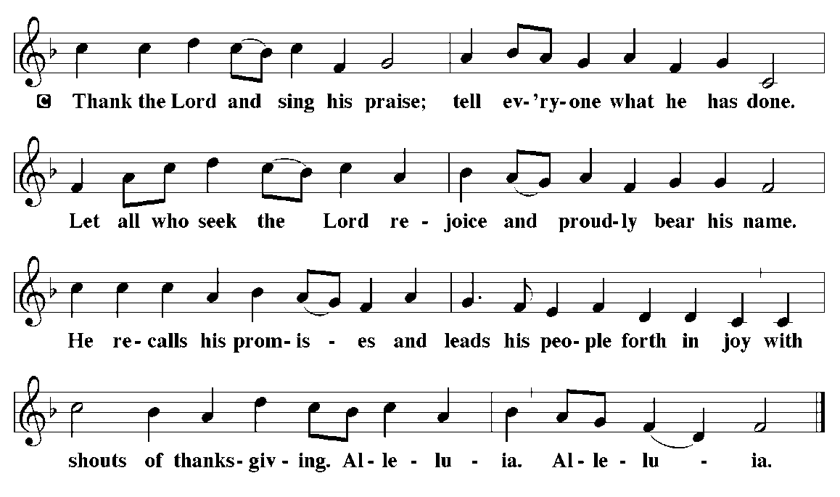
*POST COMMUNION PRAYER LBW 74
P: Almighty God, You gave Your Son both as a sacrifice for sin and a model of the Godly life. Enable us to receive Him always with thanksgiving, and to conform our lives to His; through the same Jesus Christ our Lord.
*BENEDICTION LBW 74
*RECESSIONAL HYMN | Lord, You Give the Great Commission | WOV 756
*SENDING
P: Go in Peace and serve the Lord.
C: Thanks be to God.
*POSTLUDE: | Christ lag in Todesbanden | J. S. Bach

Pastor Ian Reid Cantors Shandra Ice & Paul Freeman
Organist Sherry Fosselman Piano Carolyn Anderson
Lector Tim Archer
Crucifer Eli Reid Acolyte Caleb Reid
Videographer, Sound, and Lighting… Doug Woolley

- Flowers on the Altar for this Sunday are given in memory of JP & Juanita Vaughan from Ed & Becky Vaughan
- Flowers on the Baptism Font this Sunday are given in honor of Rand Butler’s birthday from his sisters, Cindy, Mollie, Becky & Susan.

