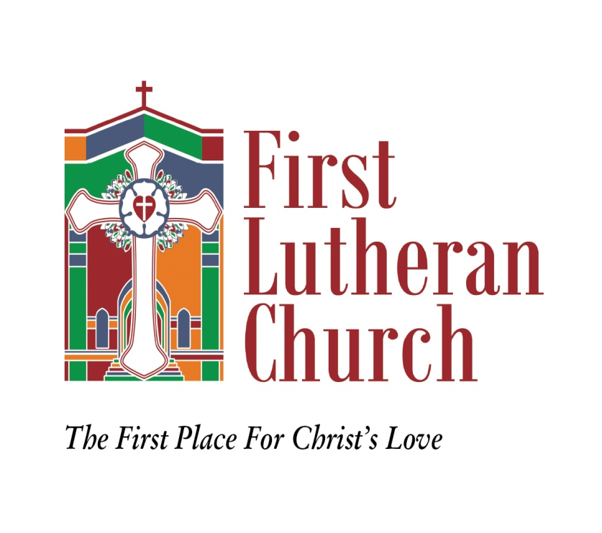

WEDDINGS AT
FIRST LUTHERAN CHURCH
POLICIES AND PROCEDURES

MEMBERS

Rev: 07/27/16

TABLE OF CONTENTS

Page

General Guidelines for Weddings at First Lutheran Church 3

You and Your Wedding Date 5

Fees/Items Available/Sound System 6

First Lutheran Church Sanctuary Usage 7

Wedding Party 9

Wedding Day Schedule 10

Wedding Reception Policy 12

First Lutheran Church
1701 – 19th Street
Parkersburg, West Virginia 26101
304/428-6174

GENERAL GUIDELINES FOR WEDDINGS AT FIRST LUTHERAN CHURCH

We know that this is an exciting time for you as you prepare for your life together. Our hope is that this day will have deep spiritual meaning for you, as a member (or child of a member) of First Lutheran Church, as you make your commitment in marriage before God, family and friends at First Lutheran Church.

The First Lutheran Church (FLC) Pastoral staff is responsible for the conduct of all worship in the Sanctuary and has the right of first refusal as the presiding minister for all wedding ceremonies. If it is proposed that another ordained minister perform the ceremony, this must be pre-approved by the Sr. Pastor who will then issue the invitation. If the FLC Pastoral staff does not perform the wedding service, the wedding will be treated as a non-member wedding and the non-member brochure information, fees, etc. will apply. The Pastoral staff is also responsible for the general format of the wedding and rehearsal. If communion is to be offered, it is to be served only by an ordained Lutheran Pastor or an ordained ecumenical partner.

The Church Wedding Liaison (CWL) is the representative of the First Lutheran Church (FLC) and is your contact who will arrange scheduling for your wedding. The CWL is appointed by the Church Council and is required to assist with all weddings and receptions at FLC and to coordinate all FLC staff, resources and facilities. The CWL is responsible for the sanctity, functionality, and use of the church property during all wedding rehearsals, before/during/after the actual wedding, and any dinners and/or receptions held on church property in conjunction with the wedding. The CWL will be available to you and your wedding planner to answer questions and provide guidance relative to acceptable and proper use of the Church facility. It is the job of the CWL to help you make your wedding a beautiful and memorable occasion at First Lutheran Church.

This wedding brochure gives you guidelines on decorations, music, photography, dressing rooms, facilities, fees, and how we at FLC can be of assistance to you on your special day.

After you have discussed your wedding plans with the presiding Pastor and your wedding date has been tentatively approved, you will need to complete page 5, “You and Your Wedding Date”, and page 6. These will provide preliminary information for the presiding Pastor and the CWL. When you return the completed pages, this will confirm your intent to have your wedding on the specified date and First Lutheran will be committed to reserving that date for your wedding.

The presiding FLC Pastor will require three (3) pre-marital conferences with the prospective bride and groom. Such sessions provide opportunity for the Pastor and you to become better acquainted as you discuss matters of marriage and plan the ceremony. Call the Pastor at the Church (304/428-6174) to schedule your initial visit.

Under normal circumstances there will be no weddings scheduled the week before Christmas or Holy Week and the week following Christmas and Easter.

If you wish to have the Pastor and spouse attend the rehearsal dinner and/or the wedding reception, please provide a minimum of one month’s notice.

Alcoholic beverages and smoking are not permitted in/on the premises of First Lutheran Church, including the parking lot and the alley … and we ask your – and your wedding party and guests - cooperation in observing this.

No food or beverages are permitted in the Sanctuary.

YOU AND YOUR WEDDING DATE
(Wedding Date must be pre-approved)

Wedding Date/Date: ___________________________ Time: ____________ AM or PM

Rehearsal Date/Date: ___________________________Time: ____________AM or PM

BRIDE’S INFORMATION

Full Name: ________________________________________________________________

Contact Number: ___________________________or: _____________________________

Email: ____________________________________________________________________

Address: __________________________________________________________________

Birth Date: ___________________________________

GROOM’S INFORMATION

Full Name: ________________________________________________________________

Contact Number: ___________________________or: _____________________________

Email: ____________________________________________________________________

Address: __________________________________________________________________

Birth Date: ___________________________________

ALTERNATE CONTACT (in the event bride and groom unavailable)

Contact Name: _____________________________Relationship:______________________

Contact Number: ___________________________ or: _____________________________

FOLLOWING THE WEDDING (please note any changes)

Address: ___________________________________________________________________

Contact Number: _________________________ Email: _____________________________

PRE-MARITAL MEETINGS: Please call Pastor (304/428-6174) to schedule appointments.
FEES/ITEMS/SOUND SYSTEM
REQUIRED FEES:
- Sanctuary Rental Fee ………………………………………..no charge for FLC members
- The Presiding Pastor ……..……………………………………………………………Honorarium
- Church Wedding Liaison ………………………..…………………………………………… $200
- Sexton ………………………………………………………….…………………………………….. $100
Checks are made payable to each member of the wedding support staff

OPTIONAL WEDDING SUPPORT STAFF FEES:
- Organist ………………………………….……………………………………………………….……$200
- Sound System Operator …………………………………………….………………………….$100
NOTE: The FLC organ and sound system will only be operated by designated
FLC personnel – unless approved by Organist or Sound System Operator
Checks are made payable to each member of the wedding support staff

ITEMS AVAILABLE FOR USE (please check items needed)
___ Kneeler with white needlepoint pillow
___ Gold Unity Candle Floor Stand
___ Various wooden tables (used for sand ceremony, table top unity candle,
photos, etc.)
___ Music stands and chairs for musicians/vocalists
Music stands ________(number) Chairs ________ (number)
___ Pew Candles (includes candles) .…………………………………….……….………. $75
Check is to be made payable to First Lutheran Church

SOUND SYSTEM NEEDS:
(The acoustic properties of our sanctuary require use of microphones for all speakers and vocalists)
- How many pastors? (each need portable clip-on lapel mic) (#)______________
- How many vocalists singing at the same time? (#)______________
- How many musicians and type of instruments?
___________________________________ ______________________________
___________________________________ ______________________________
- Will vocalist(s) use back-up CDs? (bring to wedding rehearsal) Yes___ No ___
- Will there be a videographer? Yes ___ No ___

IMPORTANT NOTE: IN ORDER FOR WEDDING TO PROCEED –
ALL FEES MUST BE PAID IN FULL ONE WEEK PRIOR TO WEDDING DATE

I have read and understand the policies and procedures outlined here:

_____________________________________(signature)
ADDITIONAL COMMENTS: (over)
FIRST LUTHERAN CHURCH SANCTUARY USAGE

SANCTUARY DIMENSIONS:
Center Aisle width – 4’9”
Aisle length – 68’2” (from entry of sanctuary to steps before chancel)
Pews: 20 rows (10 pairs of pew candles)
Maximum Seating Capacity: 450 individuals

FRONT DOOR to NARTHEX - 13’10” … to SANCTUARY STEPS - 68’2”

INVITATION INFORMATION:
Church address: First Lutheran Church, 170l – 19th Street, Parkersburg WV 26101
Pastor: The Reverend Ian B. Reid

FLOWERS/DECORATIONS/CANDLES
Decorations must not interfere with Christian symbolism and/or the Sanctuary furnishings. The Altar paraments will not be changed for weddings. Nothing is to be affixed to the Sanctuary or any furnishing in the Sanctuary by staple, nail, hot glue, tape or any other fastener or substance that will mar the surface or finish. Ribbon, string or rubber bands are suitable fasteners. Nothing in the Chancel area or Sanctuary may be moved or altered without the approval of the Pastor or the CWL.

Only live flowers are to be placed on the Altar. All other floral decorations may be live or artificial. Have florist notify Church Wedding Liaison (CWL) of delivery time to have doors open. Pews/pew candles may be decorated. Decorating may be done the day before depending on other Church events. Flower girls(s) may only drop silk flowers down the aisle.

All candles used in the wedding service must be dripless candles – with the exception of the ‘unity candle’ if one is included in the service.

ALL FLOWERS/DECORATIONS MUST BE REMOVED FOLLOWING THE SERVICE.

WEDDING REHEARSAL/WEDDING LICENSE
The rehearsal is usually scheduled the evening before the wedding, between 5 pm and 7 pm.
Musicians/vocalists should be at the rehearsal to do sound checks and set ups.
Bring the LICENSE to the rehearsal. (Must be over 24 hours from time of issue!)
Bulletins/other printed materials are the responsibility of wedding party.

MUSIC
A wedding held at First Lutheran Church is a religious, not a secular ceremony. The music selected should reflect the religious nature of the ceremony. Music selection(s) should be cleared with the organist and the Pastor. The FLC organist shall play for all weddings unless other arrangements are made with, and approved by, the FLC organist.

DRESSING ACCOMODATIONS
The parlor in the educational building is provided for the bridal party to dress.
The groom’s party may use a classroom in the upstairs of the educational building
to prepare.

The Church cannot accept responsibility for any personal items. It is imperative that money, jewelry, and other valuables not be left unattended in the bride’s or groom’s rooms.

PHOTOGRAPHERS/VIDEOGRAPHERS
Photographers will be instructed by the CWL where they may take photos during the ceremony.
Camera flash is not allowed during the service.
Photo sessions may be done before or after the ceremony.
Videographers are to work with the Sound System Operator.

DEPARTING THE CHURCH
Bird seed or bubbles are acceptable outside the church. Rice, confetti and the like are not permitted due to safety concerns.

FACILITY CLEAN-UP
Our sexton does vacuuming and general cleanup of the sanctuary and dressing rooms following the ceremony. All decorations and flowers must be removed by wedding party to allow sexton to clean Sanctuary in preparation for Sunday services. Any decorations or personal items remaining at the Church after one week will be destroyed.

NOTE: Alcoholic beverages and smoking are not permitted in/on the premises of First Lutheran
Church, including the parking lot and the alley. No food or drink is permitted in the
Sanctuary. It is the responsibility of the bride and the groom to explain the policies to their
families, wedding party, photographers and videographers or any other vendor.

WEDDING PARTY
(Give Full Names of all Participants)

MAID/MATRON OF HONOR: ____________________________________________________

BEST MAN: __________________________________________________________________

BRIDE’S ATTENDANTS:

______________________________ _________________________________

______________________________ _________________________________

______________________________ _________________________________

______________________________ _________________________________

______________________________ _________________________________

GROOM’S ATTENDANTS:

______________________________ _________________________________

______________________________ _________________________________

______________________________ _________________________________

______________________________ _________________________________

______________________________ _________________________________
JUNIOR
BRIDESMAIDS ______________________________ _________________________________

FLOWER GIRLS ______________________________ _________________________________

RING BEARERS______________________________ _________________________________

ACOLYTES ______________________________ _________________________________

READERS ______________________________ _________________________________

OTHER ______________________________ _________________________________

WEDDING DAY SCHEDULE

BRIDE/GROOM _________________________________________________________________

DATE OF WEDDING _________________________________________

TIME SCHEDULE:

______________ Bridal Party arrival time

______________ Groom’s Party arrival time

______________ Musical Prelude begins

______________ Acolytes light candles

______________ Parents/Grandparents meet in Narthex (waiting to be seated)

______________ Music begins for the seating of grandmothers and mothers

Grandmother(s) of groom seated by _____________________________

Grandmother(s) of bride seated by ______________________________

Mother of groom seated by ____________________________________

Mother of bride seated by _____________________________________

_______________ Aisle cloth unrolled by ________________________________________

_______________ The Processional

Pastor, Groom, Groom’s attendants enter

Bridal Party processes

The Recessional

Bride’s mother ushered out by __________________________________

Groom’s mother ushered out by ________________________________

Bride’s grandmother(s) ushered out by ___________________________

Groom’s grandmother(s) ushered out by __________________________

Congregation Dismissal (3 options)

___Row by row dismissal, ushered by _____________________________

___Row by row dismissal by bride and groom

___No formal dismissal

FIRST LUTHERAN CHURCH
WEDDING RECEPTION POLICY FOR CHURCH MEMBERS

First Lutheran Church is eager to make your wedding a beautiful and memorable occasion. The following information is to help you in planning for the important event. The Church Women have a Wedding and Reception Committee to assist you. Please contact the Church Wedding Liaison (CWL) who, with the church reception chairman, will assist you with planning your reception.

The Church is unable to underwrite the extra costs incurred for a wedding reception. Fees for the extra services are as follows:
No charge for use of the Church Fellowship Hall
Sexton’s Fee (additional set-up, cleaning required) …………………………………………. $100
Church Wedding Liaison (additional planning/coordination)……………………………… $100

Cake/Punch Reception by Committee (maximum 100 guests)………………..……………$125
150 guests ….. $175 200 guests ….. $225
(Cake, punch supplies, napkins provided by wedding party,
Committee will set up, serve, clean up)
Reception with Food:
Light Foods (provided already prepared/no cooking) …………….………………. $175
Committee will set up, serve, clean up.
Dinner – use of kitchen equipment and appliances ……………………………….. $400
Wedding party is responsible for food, cooking and clean up.
Committee will set up and serve.

Rehearsal Dinner: negotiable

Table linens: cleaned professionally: 5’ rounds ………….. each $8.00
8’ rectangles……… each $11.00

SOUND: Sound is available for reception by FLC sound system operator. Please call for availability. Price is $100. This includes videographers who wish to use sound system.

Bride’s Responsibility for Reception:

Refreshment items should be brought to the Church by NOON the day before the wedding, as well as napkins, nuts, mints, beverage(s) ingredients of your choice for punch, coffee, cream & sugar, tea, etc.

Reception decorations shall be done one day prior to the wedding and time should be scheduled with the reception chairman. All decorations must be removed following the reception so facility is available for Sunday worship.

Make arrangements with the reception chairman to have the wedding cake delivered. The bride is to be present when the cake is set up, to ensure that it is to her satisfaction.

The bride must have someone responsible to pick up the remainder of the reception foods, napkins, gifts, etc., immediately following the reception.

It is the policy of First Lutheran Church and the Church Women’s wedding and reception committee that the Church’s china, crystal, silver, tablecloths, and kitchen ware will not be removed from the church building under any circumstances.

Alcoholic beverages and smoking are not permitted in/on the premises of First Lutheran Church, including the parking lot and the alley … and we ask the cooperation of you and your wedding party and guests in observing this.

