Robert Louis Storck Memorial Scholarship

Bread of Life Committee created a scholarship to honor the memory of Robert Louis Storck. A tribute to his life is attached to the scholarship information. Robert Storck generously gave of his time, leadership, and finances to the Wood County community. Your community services will weigh highly upon receiving this scholarship.

Who can apply?
- Any high school senior or graduate of an accredited high school, residing in Wood County, West Virginia.

- Applicants must exemplify good moral and spiritual character and good citizenship.

- Applicants must be attending or planning to attend a training from an accredited instructor or educational institution; awards can be for ANY level or type of training such as vocational, apprenticeship programs, to improve literacy skills, artistic development, secretarial skills, college level, graduate level, seminary studies, sabbatical leave to pursue special goal or internships.

How to apply?
- Applicants must submit:
  - Signature letter and completed checklist.
  - Completed Application Form
  - Essay to include:
    - A glimpse of your family and growing up years
    - School experiences and accomplishments
    - Community service and volunteer activities
    - End your essay with how this scholarship will inspire you to give back to the Mid-Ohio Valley community.
  - Current High School transcript

- Applications can be mailed to:
First Lutheran Church
1701 19th Street
Parkersburg, WV 26101

- OR applications can be emailed to: flcsec@yahoo.com subject line Bread of Life Scholarship

When to apply?
- The deadline is April 17, 2026

Additional Information:
The average award is approximately $500. The committee shall meet and determine the recipients of the scholarship prior to the awards day at local schools so that scholarships can be presented on those occasions. All monies from the Robert Louis Storck Memorial Scholarship fund are grants and made for education and need not be repaid. Students are asked to remember on the completion of their education the value of helping others and are encouraged to help other deserving individuals.

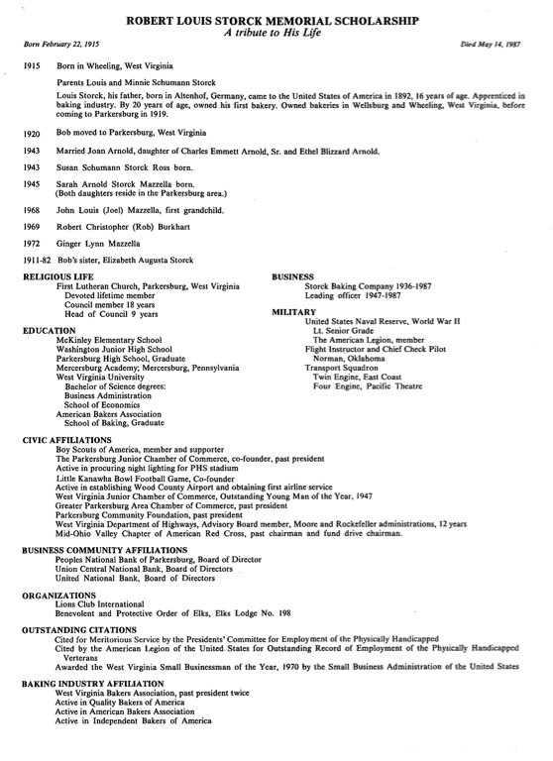

ROBERT LOUIS STORCK
MEMORIAL SCHOLARSHIP

To: Bread of Life Committee

Please accept the attached application. The required information is enclosed:
- Signature letter (this page)
- Application Form
- Essay
- Current High School Transcript

Sincerely,

_______________________________________________________________

CHECKLIST

_____ Signature letter and this checklist

_____ Application

_____ Essay

_____ Transcript

Date Application Sent _______________________________ (deadline 4/18/25)

BREAD OF LIFE SCHOLARSHIP
FIRST LUTHERAN CHURCH
APPLICATION FORM

Please Type or Print
Name: __________________________________________________ Date: _________________________
Address: _______________________________________________ Phone: _______________________
__________________________________________________ Birth Date: ____________________

Education: Name: City: Grad. Date: GPA:
Secondary School ____________________________ _________________ _______________ ______
College ____________________________ _________________ _______________ ______
Other ____________________________ _________________ _______________ ______

Employment (Beginning with most recent)
Employer: Address: Position: From/To: Avg. Hrs.
_________________ ____________________________ ________________ _______________ ______
_________________ ____________________________ ________________ _______________ ______

References:
Name: Address: Occupation: Years Known:
______________________ ____________________________ ______________________ ____________
______________________ ____________________________ ______________________ ____________
______________________ ____________________________ ______________________ ____________

Name of College(s)/Universities to which you are applying: _________________________________________
__________________________________________________________________________________________
Location (City and State): ____________________________________________________________________
Major Field of Study: ________________________________________________________________________
Circle Classification for the upcoming year:
A. Private Institution Apprenticeship Vocational Public Institution
B. Freshman Sophomore Junior Senior Graduate
Explain any special circumstances not covered by any other parts of this application:
__________________________________________________________________________________________
__________________________________________________________________________________________

IMPORTANT: PLEASE ATTACH A COPY OF YOUR TRANSCRIPT TO THIS APPLICATION ALONG WITH YOUR LETTER ABOUT YOURSELF!

